Dear Parents

Art Competition
For Reception to Year 6. The Royal Horticultural Society is celebrating 60 years of Britain-in-Bloom this year.
Their celebration theme is "Friendship and Celebrations".
Children are invited to create a painting up to A3 size. You can use paints, collage or pastels. They do not advise felt-tips. Can you create an artwork celebrating flowers, wildlife, gardens and friendships blossoming? Please hand in your named artwork to Mrs Ross in Squirrel Class by Thursday 14th June. There will be prizes for the best artwork in: Reception/Year 1 and Years 2/3 and Years 4/5/6. The best ones from each section will go on to the Britain in Bloom regional competition. Please ask if you need any help with this.

Sports Day
Years 4, 5 and 6 Thursday 20th June AM
Year 1, 2 and 3 Thursday 20th June PM
Early Years (Nursery & Reception) Friday 21st June AM
We will confirm times nearer the date.

Reading Raffle
Key Stage 1
Winners: Badger 61%
2nd Place Squirrel 60%
Key Stage 2
Winners: Falcon 89%
2nd place: Turtle 68%

Top Class Attendance for last week

Dolphin | 97.9%
Eagle | 97.5%

Top Doodling Classes
Doodle Maths
Squirrel | 70%
Dolphin | 69%
Falcon | 64%

Doodle Tables
Falcon | 71%
Eagle | 68%
Butterfly | 48%
Star Learners
Well done to this week’s Star Learners
Class | Name | School Value
Dolphin | Ruby Sims | Collaboration/Respect
Monkey | Chloe Doku | Respect
Dragonfly | Troy Amos | Ambition
Turtle | Sonny Scurlock | Respect
Panther | Jackson Waldron | Ambition
Butterfly | Iga Boron | Creativity
Eagle | Tommy Swift | Resilience
Falcon | Riley Bishop | Respect
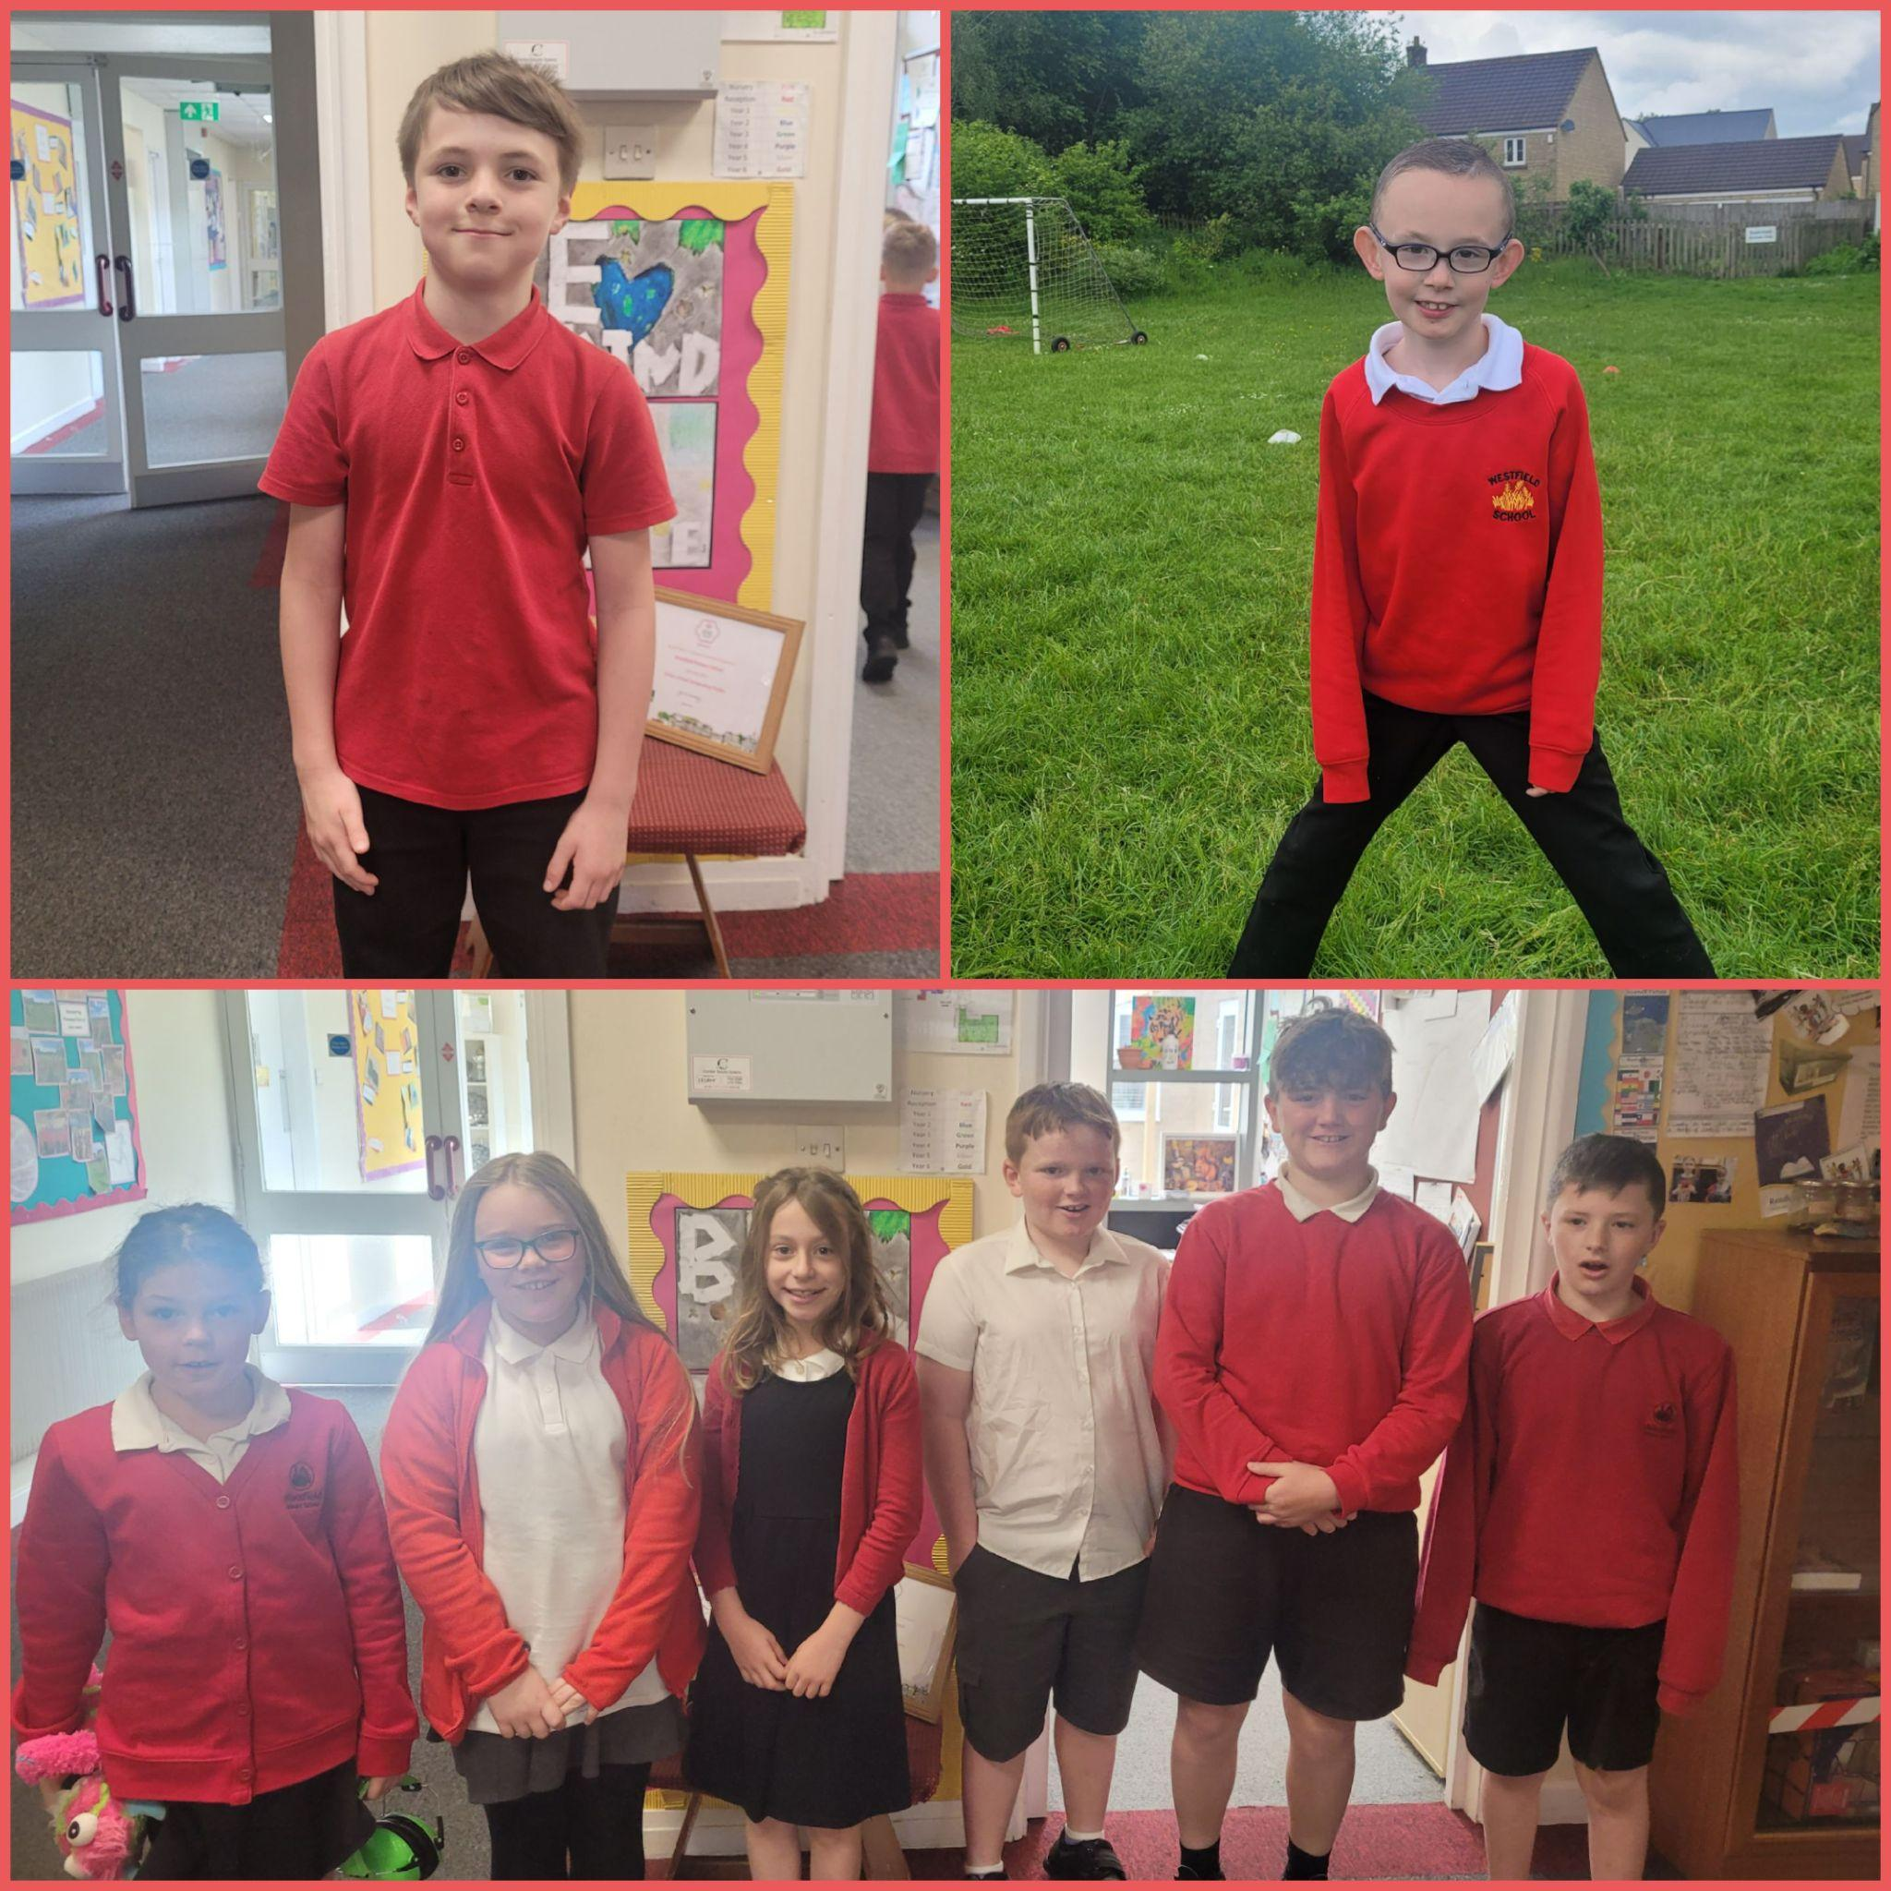

Raffle Winners
Congratulations to our term 5 raffle winners who have been picked from our reading and doodle maths boxes.
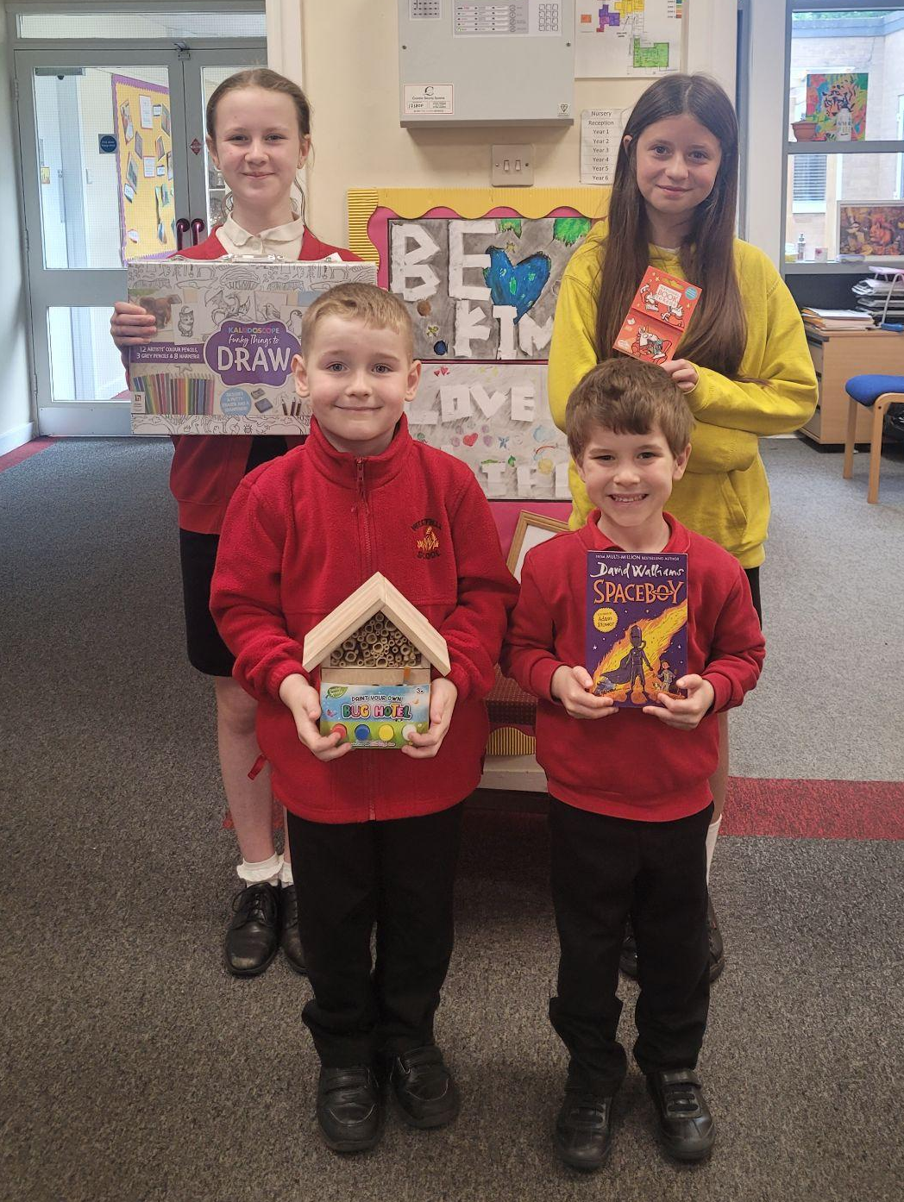
Diary Dates

May

Fri 24 Last day of term
Mon 27 - Fri 31 Half Term

June

Mon 3 Start of term 6
Fri 7 Year 3 Sleepover
Thur 20 School Sports Day
Fri 21 EYFS Sports Day

July
Fri 5 Summer Fayre
Thur 11 Year 6 Production performance
Wed 17 Year 6 Service St Peter’s
Fri 19 Pupils break up for Summer

September
Mon 2 Inset Day
Tues 3 Pupil return to school

