Dear Parents

Young Artists - Monster Madness

Well done to our pupils from Sun Down Club. Artwork has been chosen to be published in a children's book called Monster Madness! All of the monsters were designed by children attending Sun Down Club and we can't wait to see the finished book!
Jasmine Kingamn - Bumblebee
Jake L’Esteve - Falcon
Bonnie Scurlock - Monkey
Lycus Denning Kuijper - Eagle
Camille Trouche - Butterfly
Lilly Curtis - Owl
Alana Obi - Hedgehog
Taiya Preddy - Butterfly

Sports Day
Years 4, 5 and 6 Thursday 20th June AM
Year 1, 2 and 3 Thursday 20th June PM
Early Years (Nursery & Reception) Friday 2st June AM
We will confirm times nearer the date.

Sun Down Club
Please can we remind all parents/carers that your child’s space for Sun Down Club must be booked in advance (You have until 6pm the evening before to book in) We have had several children arrive this week without being booked in.
In the event that you cannot book ahead, parents must phone the office to confirm there is available space for your child to attend.

Midsomer Norton Town Show
If you are interested in any of the below, then please have a chat with Mrs Phillips to complete the relevant forms.
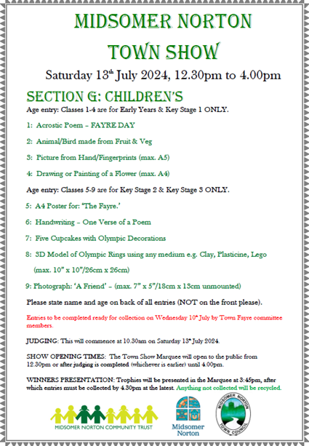

Reading Raffle
Key Stage 1
Winners: Panda 65%
2nd Place Badger 61%
Key Stage 2
Winners: Falcon 89%
2nd place: Eagle 75%

Top Class Attendance for last week

Eagle | 98.9%
Squirrel | 97%

Top Doodling Classes
Doodle Tables
Falcon /Eagle | 68%
Butterfly | 59%
Dragonfly | 55%

Star Learners
Well done to this week’s Star Learners

Class | Name | School Value
Dolphin | Macey Doman | Resilience/Ambition
Monkey | Ervanur kaya | Ambition
Dragonfly | Eddie Sharpe | Resilience
Turtle | Maxson Purnell | Respect
Panther | Lola Tadd | Resilience
Butterfly | George Moffatt | Ambitio/Respect
Eagle | Amy Emery | Resilience/Ambition
Falcon | Toby Murray | Ambition

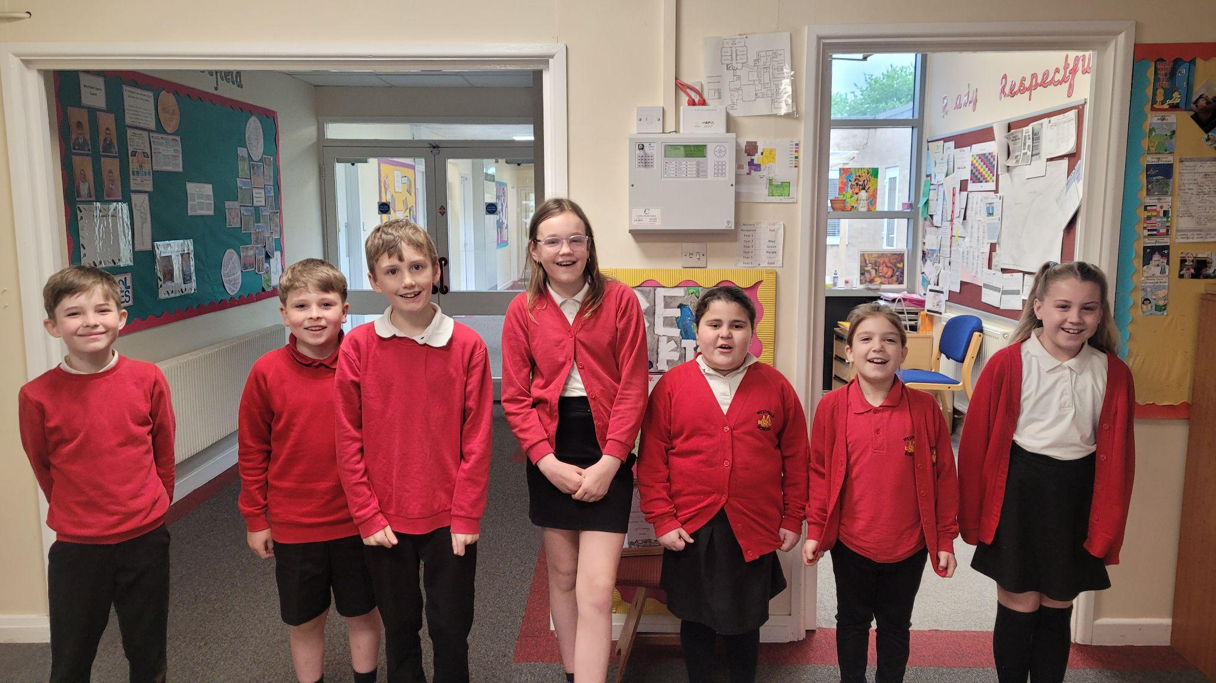

Diary Dates

May

Mon 6 Bank Holiday
Wed 8 - Fri 10 Year 4 Camp
Thur 9 Year 3 Stay and Calculate Workshop
Thur 9 Reception Heights & weights
Mon 13- Fri 17 Year 6 SATS week
Mon 27 - Fri 31 Half Term

June

Mon 3 Start of term 6
Fri 7 Year 3 Sleepover
Thur 20 School Sports Day
Fri 21 EYFS Sports Day

July
Fri 5 Summer Fayre
Fri 19 Pupils break up for Summer

September
Mon 2 Inset Day
Tues 3 Pupil return to school

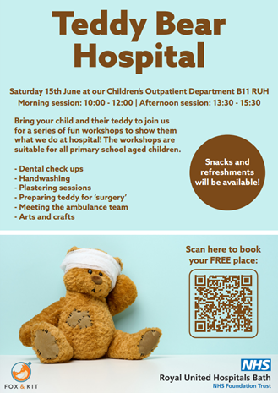

The Royal United Hospitals Bath Paediatric department is running an event called “Teddy Bear Hospital” on Saturday 15th June. They are inviting primary school children from the surrounding area to bring their poorly teddy to the “Teddy Bear Hospital”
and join them for a day of exciting and educational health-related activities, crafts and games. This will include looking inside a real ambulance and getting Teddy's broken arm plastered!

