Dear Parents

Bikeability
A reminder to all parents in Year 4 and Year 5 at the moment. If you would like your child to take part in Level 1 and 2 Bikeability training, please complete the following link by Wednesday 3rd September. A link and further information has also been sent via Weduc.
Any questions please see Mrs Bowery. https://forms.office.com/e/DSPk37m3NA

Lunchtime Award Winners
A little later than planned but congratulations to our lunchtime award winners for term 5 who were treated to a take away drink from the cafe.

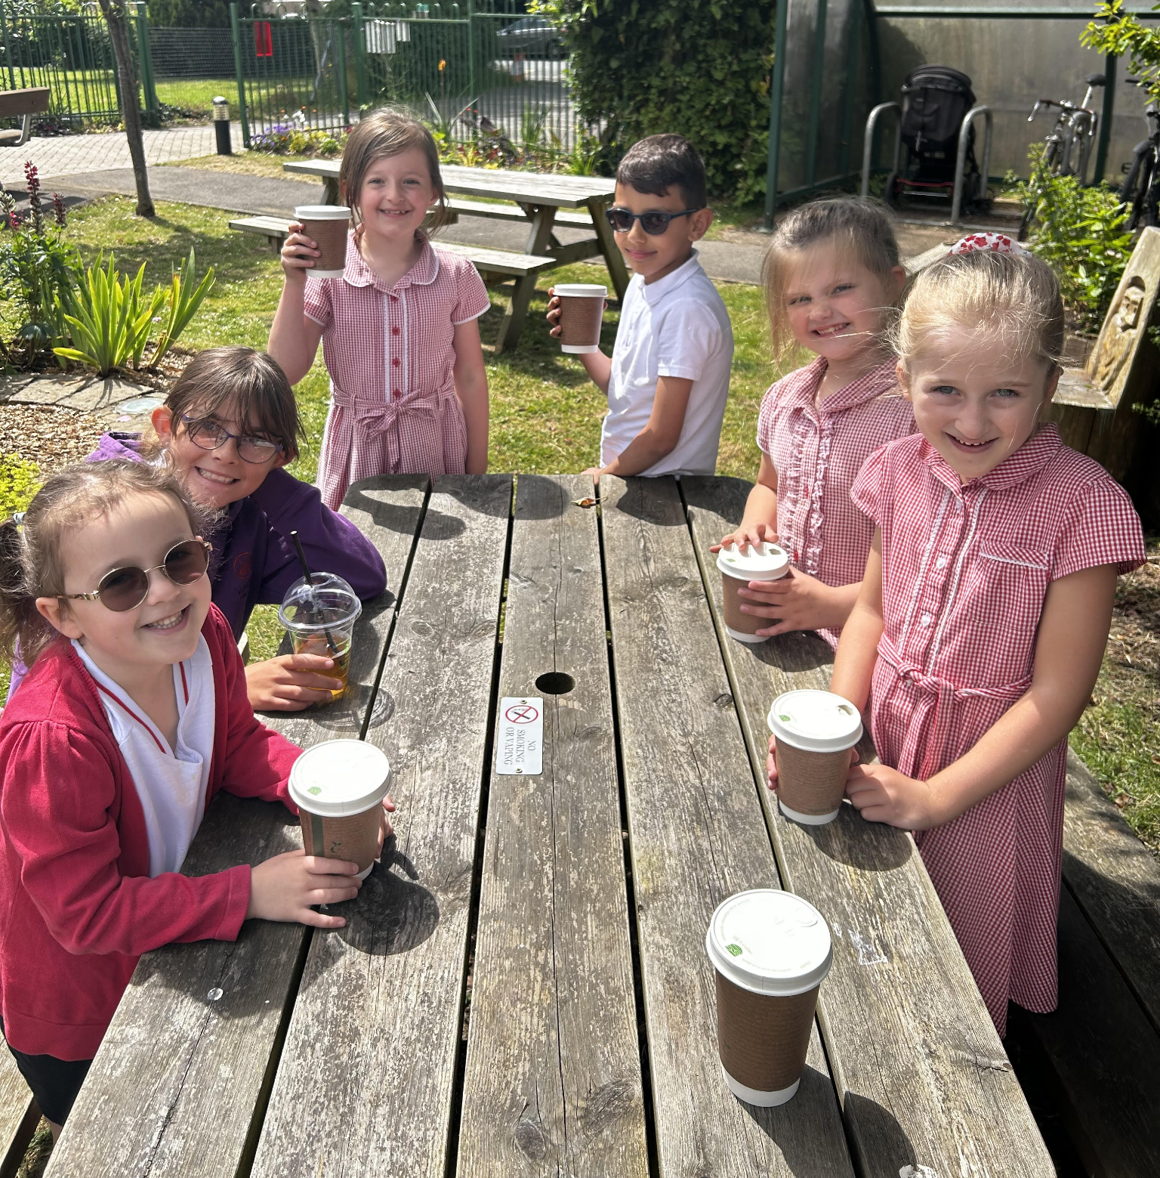

Top Class Attendance for last week

Butterfly | 97.5%
Rabbit | 96.8%

Reading Raffle
Key Stage 1
Winners: Badger 66%
2nd Place Squirrel 57%
Key Stage 2
Winners: Falcon 86%
2nd place: Eagle 82%

Top Doodling Classes

Doodle Maths
Falcon | 64%
Dragonfly | 58%
Squirrel | 52%
Doodle Tables
Falcon | 75%
Dragonfly | 65%
Eagle | 57%

Star Learners
Well done to this week’s Star Learners
Class | Name | School Value
Dolphin | Nicoleta Ristea | Resilience
Monkey | Evie Rodd | **Everything**
Dragonfly | Finley Long  Millie Green | **Everything**  Ambition
Turtle | Scarlett Wisbey | Resilience
Panther | Issy Freeman | Ambition
Butterfly | Camille Trouche | **Everything**
Eagle | Freya Dickenson | Collaboration
Falcon | Sienna Whelan | Respect/Collaboration
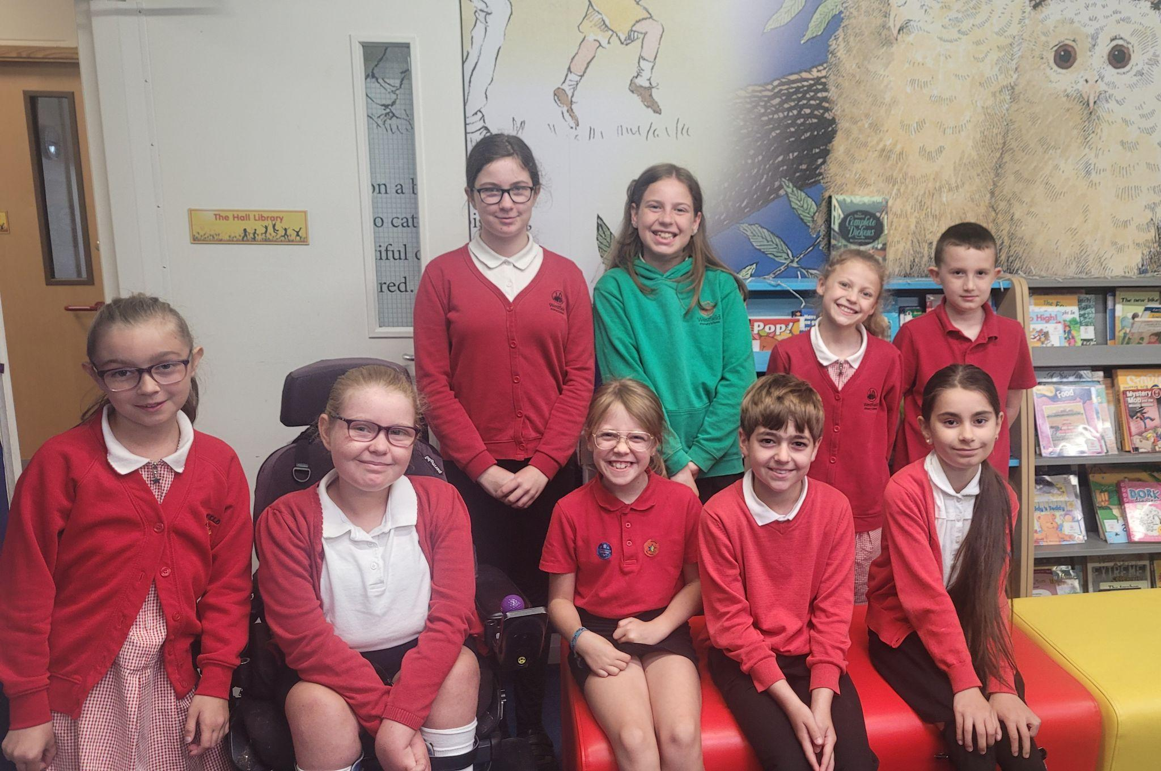

Diary Dates

July

Fri 5 Summer Fayre
Mon 8 Fantastic Futures Week
Tue 9 Year 6 Camp Meeting
Thur 11 Year 6 Production performance
Wed 17 Year 6 Service at St Peter’s
Fri 19 Pupils break up for Summer

September

Mon 2 Inset Day
Tues 3 Pupils return to school

October

Fri 25 Inset Day
Mon 28 Half Term

November

Mon 4 Pupils return to school

