**Dear Parents**

**Parents Evening**

A reminder of the dates for the upcoming Parents evenings:

* Monday 21st October
* Thursday 24th October

Appointment bookings will be live from 9am on Saturday 12th October and will remain open until 9am on Thursday 17th October

All appointments will need to be booked online using the link below

**https://westfieldprimaryschool.schoolcloud.co.uk**

**Hello Yellow**



Thank you to everyone who supported our #HelloYellow day on Thursday. We raised £128 which will go towards the amazing work carried out by Young Minds Charity.

**School Photos**

All photo proofs have now been sent home. Orders can be made either online or by returning the envelope along with the correct money.

All orders must be made by Tuesday 22nd October.

**Top Class Attendance for the week**

|  |  |
| --- | --- |
| Falcon | 99.6% |

**Top Doodling Classes**

**Doodle Maths**

|  |  |
| --- | --- |
| Dragonfly | 89% |
| Eagle | 80% |
| Squirrel | 68% |

**Doodle Tables**

|  |  |
| --- | --- |
| Eagle | 88% |
| Dragonfly | 75% |
| Falcon | 67% |

**Reading Raffle**

Key Stage 1 

Winners: Squirrel 64%

2nd Place Rabbit 63%

Key Stage 2

Winners: Eagle 92%

2nd place: Falcon 85%

**Star Learners**

Well done to this week’s Star Learners

|  |  |  |
| --- | --- | --- |
| **Class** | **Name** | **School Value** |
| Dolphin | Lexi Tadd | Ambition |
| Monkey | Cora Gobatti | Respect |
| Dragonfly | Macey Doman | Ambition |
| Turtle | Darcie Merrett | Ambition |
| Panther | Paige Gane | **Everything** |
| Butterfly | Bella Bushnell | Respect & Ambition |
| Eagle | Phoenix Woodland | **Everything** |
| Falcon | Sophie Macfarlane | **Everything** |

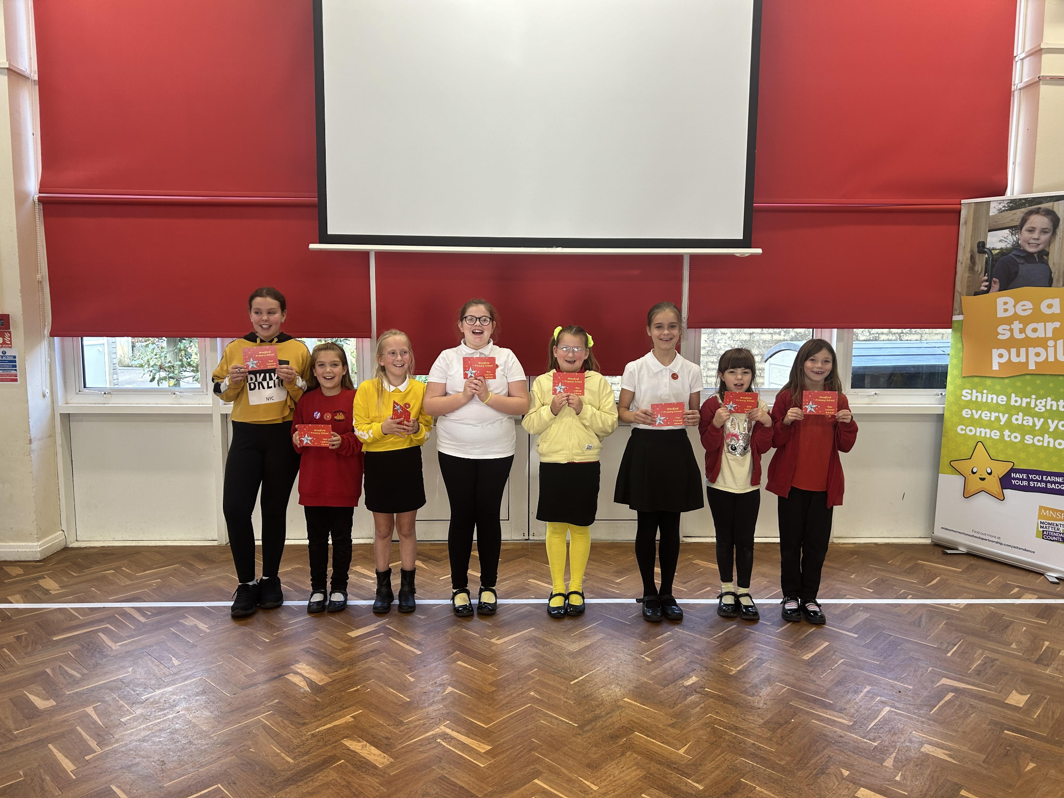

**Diary Dates**

**October**

Wed 16 School Tour 9:30am

Fri18 Spooky Chill Night - PTA

Mon 21 Parents Evening

Tue 22 Flu Vaccinations

Thur 24 Parents Evening

Thur 24 PTA Halloween Bake Sale

**Fri 25 Inset Day**

Mon 28 Half Term

**November**

Mon 4 Pupils return to school

Tue 12 Bedtime Stories - more info to follow

Tue 12 Maths Workshop Year 3

Wed 13 Maths Workshop Year 4

Wed 20 School Tour 1:30pm

**Wed 27 Inset Day**

**December**

Fri 6 PTA Christmas Fair

Fri 20 End of term

Mon 23 - Fri 3 Christmas Holidays

**January**

Mon 6 Inset Day



