
Dear Parents/Carers

Westfield Gardening Club

Westfield Primary School Garden Club has been awarded Level 4 of the RHS School Gardening Awards.

We have been using our school grounds to support wildlife by making a hibernaculum from amphibians and planting food for caterpillars. We use gardening to support the curriculum in science as well as growing our own food for cookery lessons. We also share our plants and seeds with others. We received £100 in vouchers from the RHS which we are looking forward to spending soon.
In the autumn we were awarded the Champion School for BaNES in gardening. We certainly have green fingers here at Westfield primary School, well done!

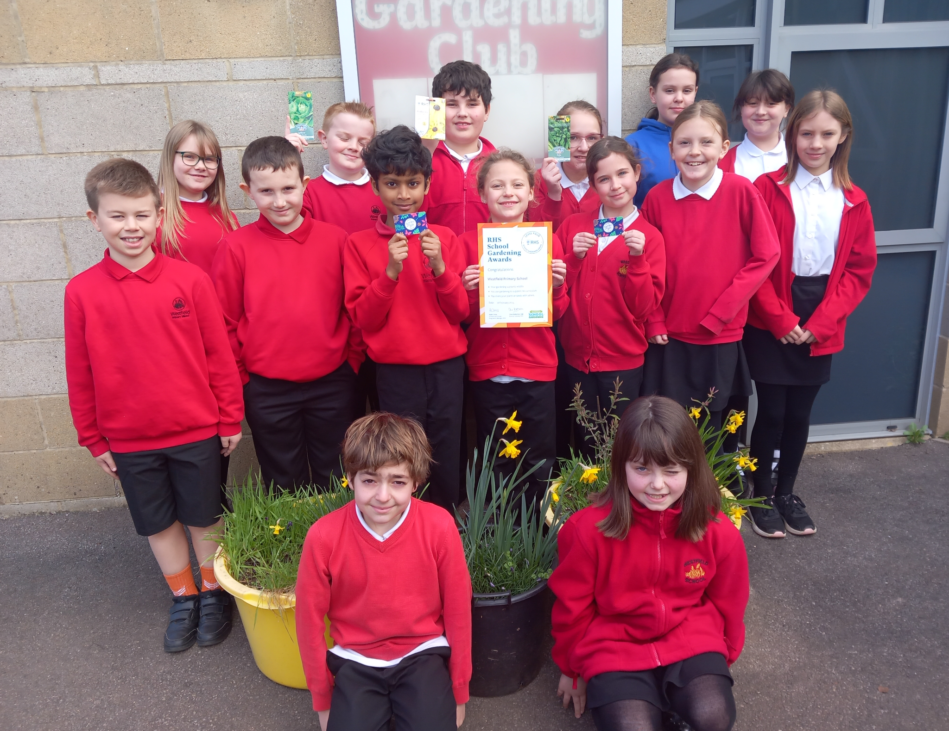

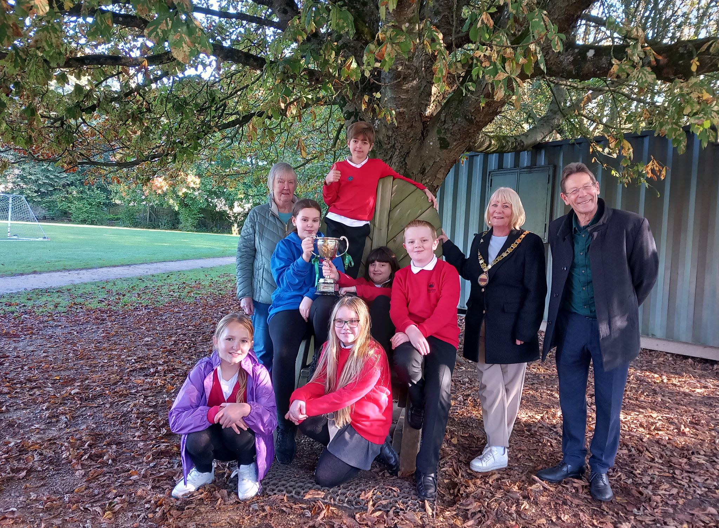

Top Class Attendance for last week

Squirrel | 99.17%
Panther | 96.6%

Top Doodling Classes
Doodle Maths
Monkey | 79%
Falcon | 67%
Badger | 61%

Doodle Tables
Falcon | 85%
Monkey | 74%
Eagle | 64%


Reading Raffle
Key Stage 1
Winners: Badger
2nd Place Panda
Key Stage 2
Winners: Butterfly
2nd place: Falcon
Star Learners
Well done to this week’s Star Learners
Class | Name | School Value
Dolphin | Lexi Tadd | Ambition
Monkey | Madison Trimnell | Collaboration
Dragonfly | Eli Barnes | Respect
Turtle | Charley Plummer | **Everything**
Butterfly | Finley Martin | Respect/Ambition
Panther | Millie Wright | Ambition
Eagle | Lincoln Parfitt | Ambition/Resilience
Falcon | Isla Hedley | Ambition/Resilience

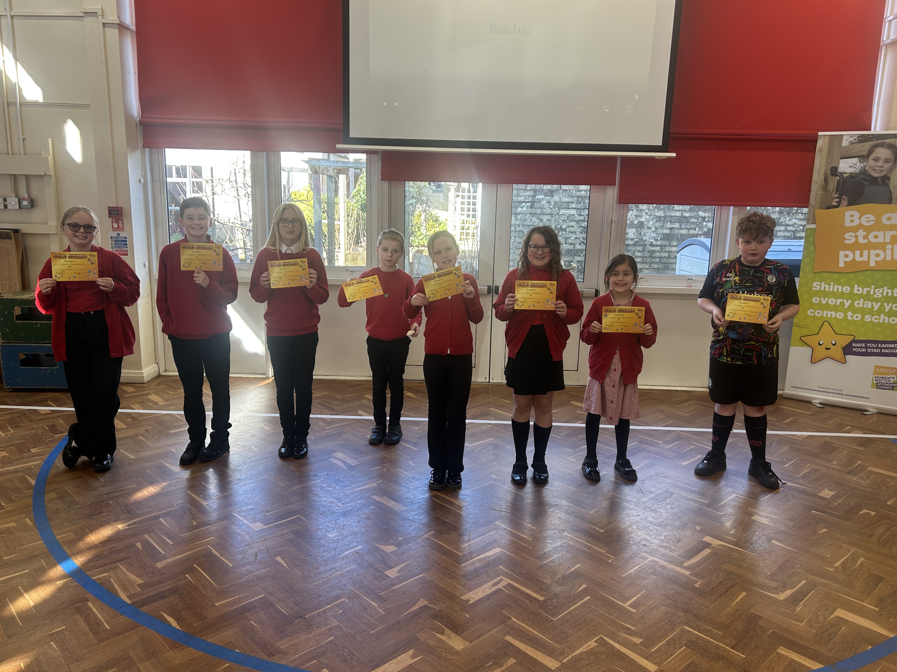
Diary Dates

March

Fri 21 Red Nose Day 2025

April
Fri 4 Last Day of term
Mon 7 -
Mon 21 Easter Holidays
Mon 21 Bank Holiday (Easter Monday)
Tues 22 Pupils return to school
Mon 28 - 30 Year 4 Camp

May
Mon 5 May Bank Holiday


